(Odoo style user manual)

**Odoo Style Application Project**

We are the Odoo Style team, and we would like to express our sincere gratitude for the opportunity to participate in the Digital Egypt Pioneers Initiative. We are excited to present our project, which we consider an important step toward improving administrative and business operations using the Odoo ERP system.

**[23-10-2024]**

**To the Digital Egypt Pioneers Initiative,**

**Odoo Style Application Project**

**Team Members:** Our team consists of a group of experienced specialists in various fields, including:

* **Waleed Ghobashy Mahmoud Saqr**
* **Sameh Ghobashy Mahmoud Saqr**
* **Ahmed Ashraf Al Kasas**
* **Mamdouh Magdy Abbass**
* **Amr Ahmed Mahmoud Khobez**
* **Mohamed Khaled**

We believe that our project aligns with the goals of the Digital Egypt Pioneers Initiative in supporting innovation and technology to foster economic growth. We are confident that the Odoo system will add significant value to organizations and enhance their competitive capabilities in the market.

We look forward to discussing further details about our project and hope to be part of this pioneering initiative.

With sincere thanks and appreciation,

**Odoo Style Team**  
NEX8_ODOOSTYLE_G1

1. **Introduction & Scope of Work**

**Project Overview:** The Odoo Style project aims to implement the Odoo ERP system across various sectors to enhance efficiency and improve resource management. The project involves analyzing the specific requirements of clients, customizing the system to reflect their unique needs, and training employees to use the system effectively.

**Objectives:**

1. **Improve Efficiency:** Utilize the Odoo ERP system to streamline operations and reduce turnaround time.
2. **Enhance Communication:** Connect different departments to facilitate the flow of information and data.
3. **Increase Transparency:** Improve access to information and data analysis to assist management in making informed decisions.

The following modules will be implemented during the application phase (installation of applications):

* Website
* Sales & CRM
* Inventory
* Manufacturing & Shop Floor
* HR (Employee / Time Off / Payroll )
* Accounting
* Purchase

**Key Challenges:**

The main challenges identified for the client are:

1. Controlling product costs.
2. Product pricing.
3. Integration between different departments to ensure quick fulfillment of customer demands.

**Implementation Order:**

Based on these challenges, the modules will be applied in the following order:

**2. Settings App**

**1. Creating Users and Assigning Permissions:**

**2. Adding Arabic Language alongside English:**

**3. Configuring Units of Measure:**

***Steps for Creating Users, Assigning Permissions, and System Setup in Odoo:***

**1. Creating Users and Assigning Permissions:**

* Go to **Settings** > **Users & Companies** > **Users**.
* Click on **Create** to add a new user.
* Fill in the user details (name, email).
* In the **Access Rights** section, select the appropriate permissions for each module based on the user’s role, such as access to Sales, Accounting, or HR management.
* Click **Save**.

**2. Adding Arabic Language alongside English:**

* From the main menu, go to **Settings**.
* In the **Languages** section, search for Arabic.
* If it's not already added, click on **Load Languages**, search for **Arabic**, and add it.
* Once added, users can switch between Arabic and English in their personal account settings.

**3. Configuring Units of Measure:**

* Go to **Settings**.
* In the **Product Settings** section, ensure that Units of Measure are enabled.
* Then go to **Inventory** > **Configuration** > **Units of Measure**.
* Create or modify the units to be:
  + **Weight in kilograms** (kg).
  + **Volume in cubic meters** (m³).

**3. Accounting**

ضبط اعدادات النظام Configuration

**(Fiscal Localization - Default Taxes -** Rounding Method - Fiscal Country – Currency-Automatic Currency Rates-

انشاء دليل الحسابات

بما في ذلك الحسابات الوسيطة

**System Configuration:**

**1. Fiscal Localization:**

* Go to **Settings** > **Taxes** or **Fiscal Localization**.
* Select the company's country to ensure tax settings and local financial laws are correctly applied.
* You can load the country's tax packages if they aren’t already available.

**2. Default Taxes:**

* Go to **Settings** > **Taxes**.
* Set the default sales and purchase taxes according to local requirements.
* Ensure appropriate taxes are applied at the product and service level for automatic application in financial operations.

**3. Rounding Method:**

* From **Settings** > **Taxes** or **Accounting**.
* Select the preferred rounding method, whether rounding up, down, or to the nearest unit.
* You can set rounding at the invoice level or on totals.

**4. Fiscal Country:**

* From **Settings**.
* Ensure the company’s fiscal country is selected to align all tax and accounting settings with local regulations.

**5. Currency & Automatic Currency Rates:**

* From **Settings** > **Currencies**.
* Set the company’s primary currency.
* Enable **Automatic Currency Rates** to update currency rates automatically based on the current market.

**6. Creating the Chart of Accounts:**

* Go to **Accounting** > **Configuration** > **Chart of Accounts**.
* Load the standard chart of accounts for the country or create a new one based on the company’s needs.
* Ensure to include intermediary accounts such as accounts payable and receivable to process financial transactions accurately.

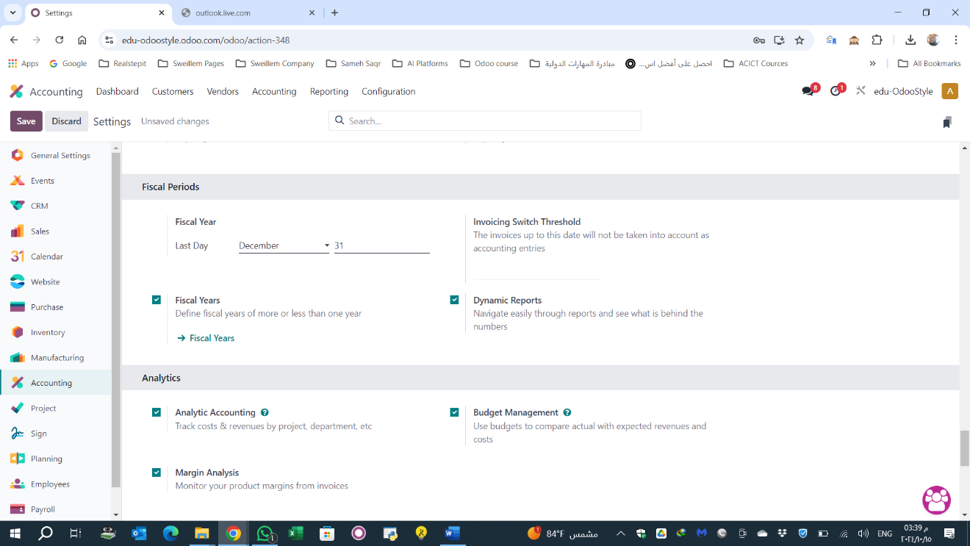

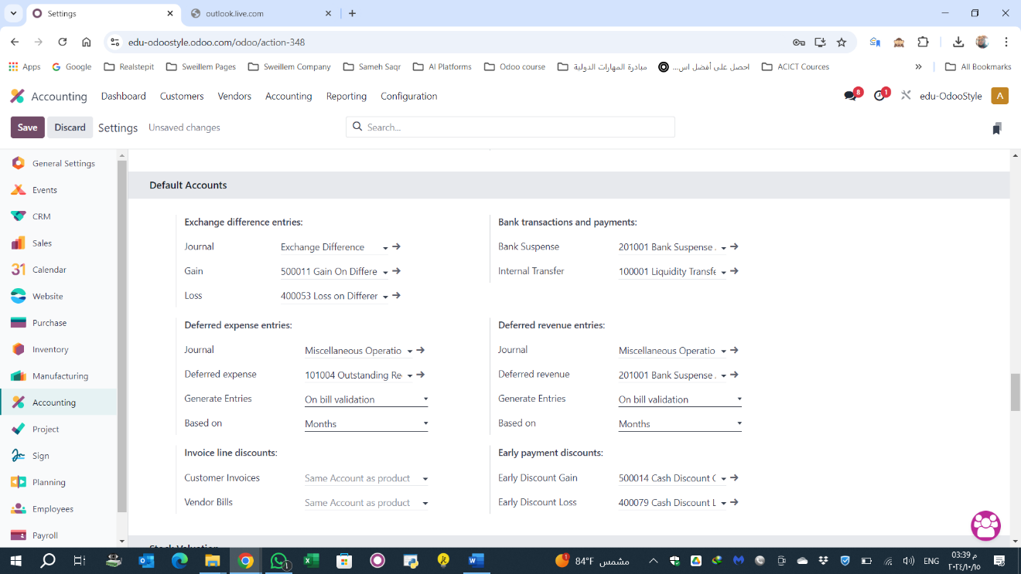

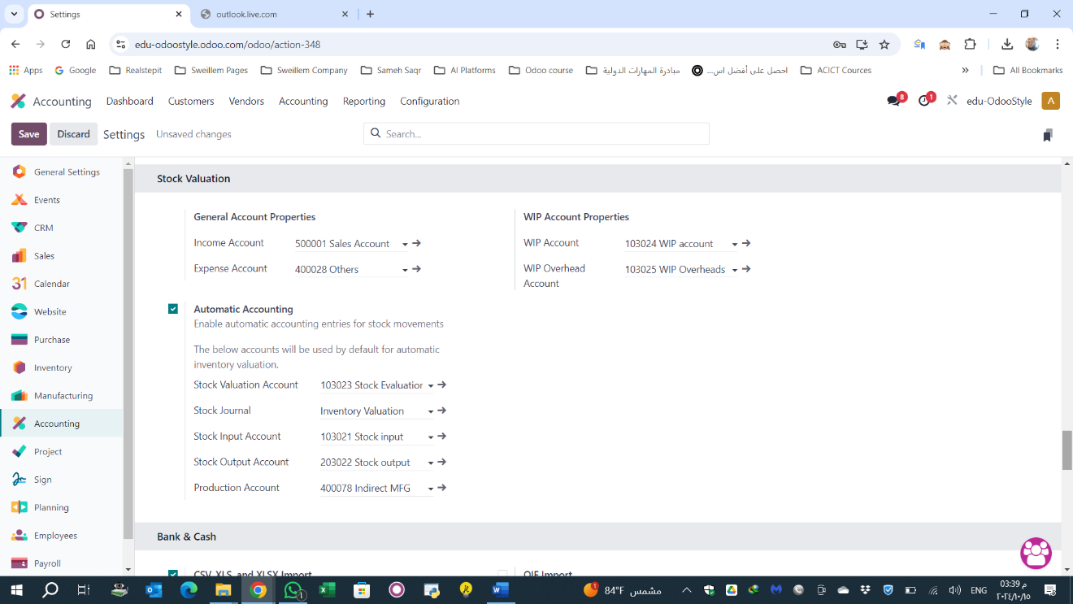

Stock in & Stock Out & Stock Evaluation & WIP Materials & WIP Overheads

تسجيل رصيد لاول المدة حسابات

**4.Inventory**

**Inventory Setup Process:**

1. **Stock Valuation Policy:**
   * Initially, the FIFO (First In, First Out) method has been adopted for stock valuation.
2. **Activated Features:**
   * **Storage Location**
   * **Multistep Routes**
   * **Unit of Measures**
   * **Landed Cost**
3. **Warehouses and Storage Locations:**
   * Enable **Variants** and **Units of Measure** for product management.
   * Enable **Landed Cost** to manage additional expenses related to inventory.
4. **Accounting Module Configuration:**
   * In the Accounting module, stock valuation will be set up using the **FIFO method**.

**Inventory Categorization:**

The client’s inventory is divided into three main categories:

1. **Raw Materials**:
   * Includes: Wood, Chemicals, Metals, Fabrics, Leather, and Upholstery Materials.
2. **Finished Products (Manufactured by the company)**:
   * Home Furniture, Hotel Furniture, Office Furniture.
3. **Purchased Finished Products (from suppliers)**:
   * Ready-made items bought from external suppliers.

**Product Categories Setup:**

1. **Parent Categories**:
   * **Raw Materials**:
     + Wood
     + Chemicals
     + Steels
     + Upholstery Materials
   * **Finished Goods**:
     + Home Furniture
     + Hotel Furniture
     + Office Furniture
     + Purchased Ready-Made Goods

**Products Setup:**

* Prepare the **Products Master Data** to upload into the Odoo system.

**Warehouse Setup:**

Four warehouses will be set up:

1. **Factory/Raw Materials Warehouse**: For storing raw materials.
2. **Factory/WIP (Work in Progress) Warehouse**: For storing products that are in the manufacturing process.
3. **Factory/Finished Goods Warehouse**: For storing completed products manufactured in-house.
4. **Furniture Showroom/Finished Goods Warehouse**: For storing finished goods in the showroom.
5. **Finished Ready-Made Goods Warehouse**: For storing purchased ready-made products.

Set up Locations

**Factory/ Raw Materials Warehouse**



**Factory/ WIP Warehouse**



**Factory/ Finished Goods Warehouse**



**furniture showroom / Finished Goods Warehouse**



**Finished Ready Made Goods**

Stock

**5.Purchase**

**Purchase Module Cycle**

1. Create new RFQ

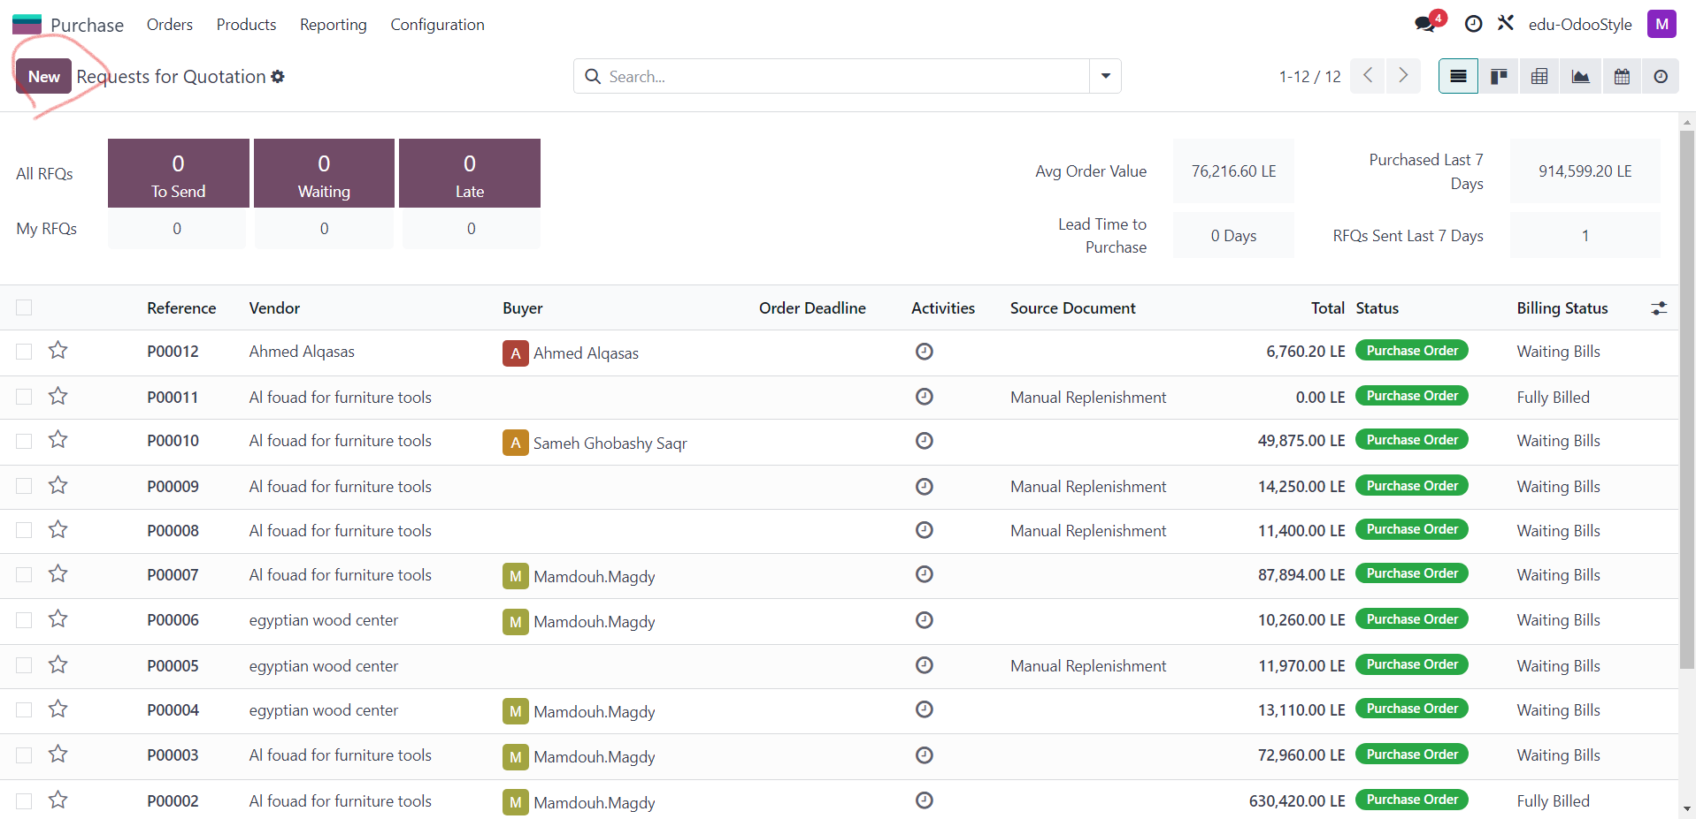

1. Choose Vendor – Product – Quantity – Price

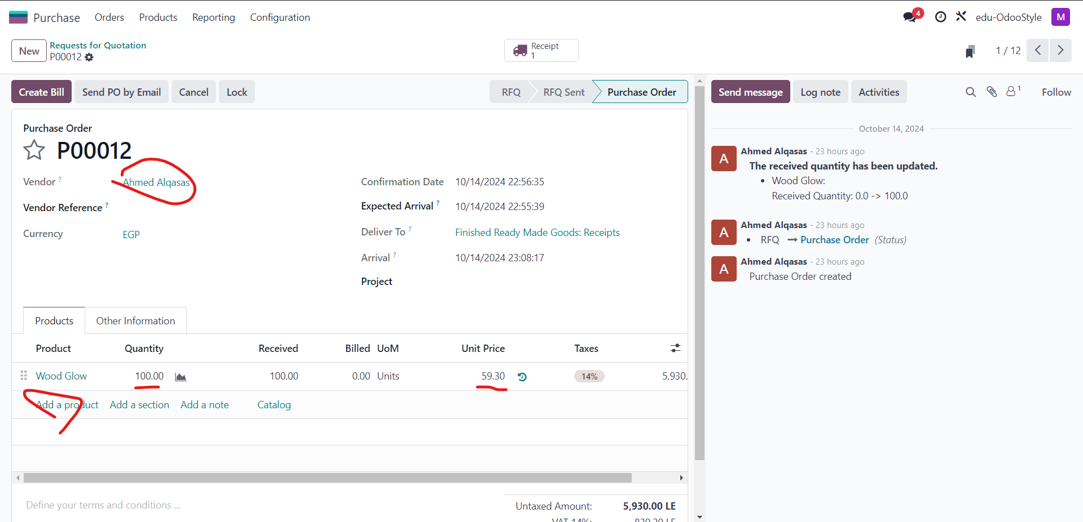

1. A screenshot of a computer

   Description automatically generatedAfter Confirming PO, Inventory Manger will Validate Quantity Received
2. After Validation, Purchase Manger Creates Draft Bill

1. Then Purchase Manger Adds Bill Date & Validated Quantity

1. A screenshot of a computer

   Description automatically generatedThen Confirm Bill, then Pay
2. Then Choose Payment Method & Journal, then Create Payment

1. A screenshot of a computer

   Description automatically generatedThen Validate Payment

**6. Manufacturing**

Furniture Manufacturing Cycle (3 Stages):

**1. Create Bill of Materials (BOM):**

Create a BOM for each type of furniture (chair, bed, wardrobe, sofa, etc.).

List all required raw materials (wood, nails, paint, etc.) and specify the quantities for each component.

**2. Add Suppliers:**

Add suppliers who provide the raw materials.

Set prices for each material to ensure accurate final product cost calculation.

**3. Purchase Orders (PO):**

Create purchase orders (POs) to obtain the raw materials from suppliers.

Track the receipt of these materials to ensure availability in inventory.

**4. Create Manufacturing Order (MO):**

For each furniture item, create a manufacturing order (MO) based on the BOM.

Ensure the necessary raw materials are available before starting production.

**5. Cutting Stage:**

Set up "cutting" as the first operation in the manufacturing process.

This stage includes cutting the wood or other materials to the required sizes and shapes according to the design.

Record the time needed to complete the cutting for each piece.

**6. Assembly Stage:**

After cutting, the pieces move to the "assembly" stage.

Components are assembled to form the final shape of the furniture (e.g., attaching legs, the backboard, etc.).

Define the time required for each assembly operation to manage work schedules and production efficiency.

**7. Painting/Finishing Stage:**

Once assembled, the product moves to the "painting" stage.

The furniture is painted, and any final finishing touches (e.g., varnish) are applied.

Record the time needed for this stage for each item.

**8. Stock Management:**

After painting and finishing, the final products are automatically updated in the inventory system.

The products are now ready for delivery or storage.

**9. Production Tracking & Delivery:**

Monitor the production schedule to check the expected delivery times.

Set the final delivery timelines based on raw material availability and the time required for each manufacturing stage (cutting, assembly, painting).

Additional Notes:

You can improve efficiency by assigning different work centers for each stage (cutting center, assembly center, painting center) to speed up the processes.

Consider adding quality checks at each stage (e.g., checking pieces after cutting and assembly) to ensure there are no errors in the final product.

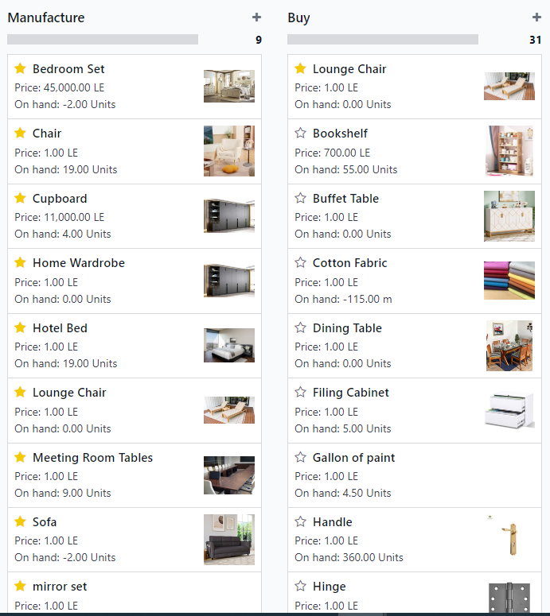

**Manufacturing Route**: to create production orders inside the factory

**Buy Route**: Ready-made products purchased to integrate with what has been manufactured to complete customer orders

The cost of items is calculated in two parts

Cost of components (raw materials)

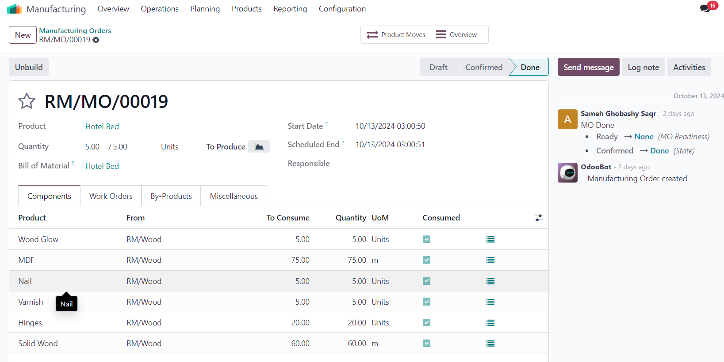

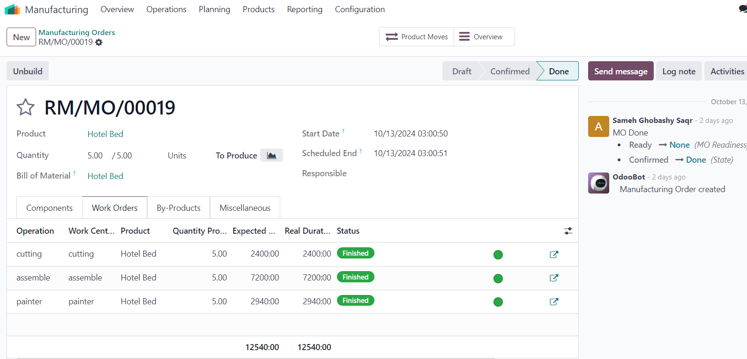

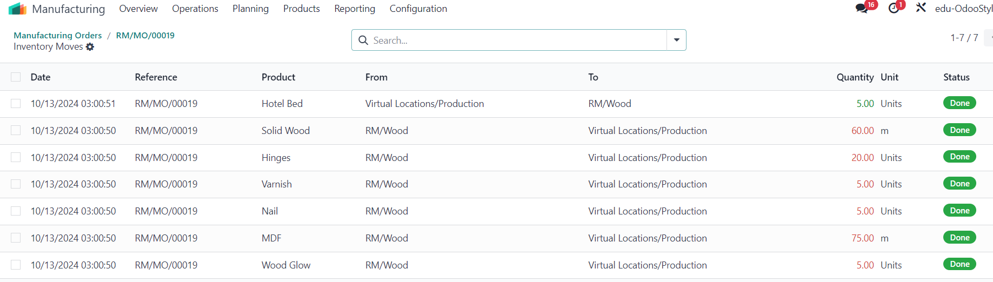

Cost of operations (the cost of each stage per hour is allocated to the product)

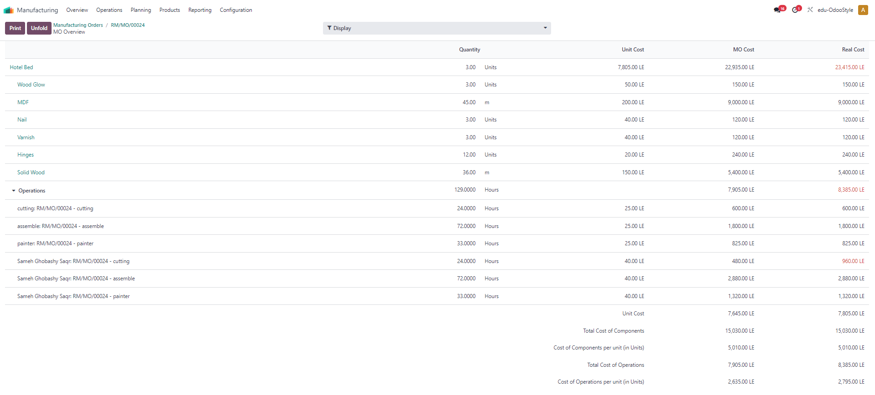

**7. CRM**

**A typical **sales cycle for a furniture company** includes the following stages:**

* **Initial Interest (Lead):**
  + At this stage, the customer becomes aware of the furniture products, either through a showroom visit, the company’s website, or marketing campaigns.
  + Basic contact information about the potential customer is collected and entered into the system as a "Lead."
* **Qualification:**
  + The customer’s needs are evaluated, such as the type of furniture they are looking for and their available budget.
  + The goal is to determine how serious the customer is about making a purchase, and if they truly need the furniture or are simply inquiring.
  + This stage helps filter qualified customers for serious follow-up.
* **Proposal:**
  + Once the customer’s interest is confirmed, a detailed price quote is provided, including the products the customer wants, quantities, and other details like material specifications and prices.
* **Negotiation:**
  + During this stage, negotiations may take place regarding prices, quantities, or payment and delivery terms.
  + The goal is to reach a mutual agreement that satisfies both parties and leads to a successful deal.
* **Close the Deal:**
  + After reaching an agreement, the deal is closed by confirming the sales order.
  + The transaction is documented in the system and converted from a sales opportunity into an actual order.
* **Invoicing and Delivery:**
  + After closing the deal, an invoice is generated for the customer based on the order.
  + The furniture delivery is scheduled to the customer’s location according to the agreed terms.
  + The order status is tracked until delivery is completed and payments are collected.

**8.Website & Sales**

**Admin Roles**

1. Website App installation.
2. Publishing sales Products.

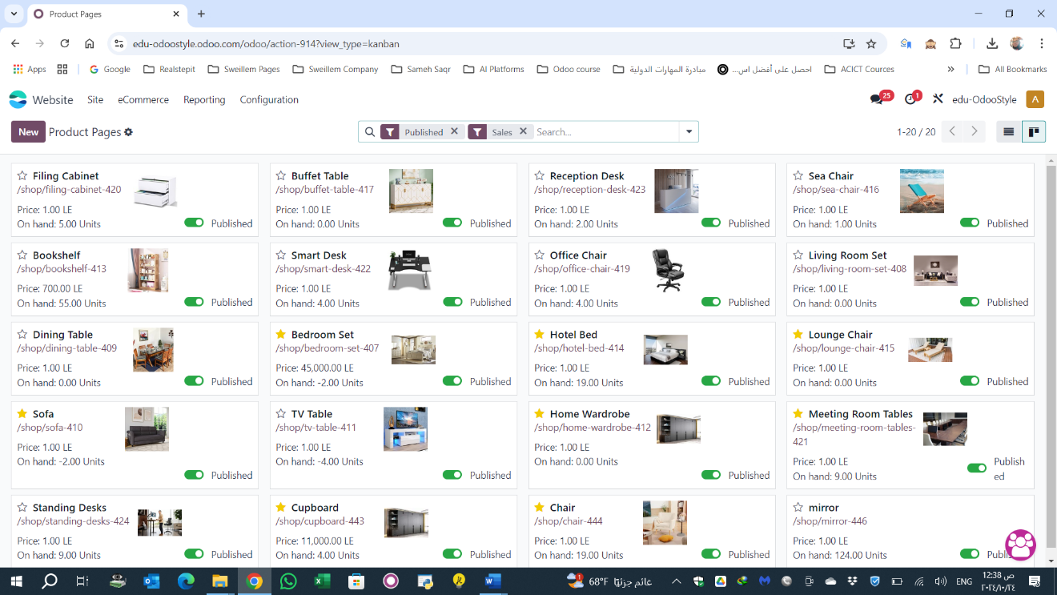

1. Creating Online Price list using a formula according the pricing Strategy Decision.

**Front End User**

1. Customer will explore website shop.

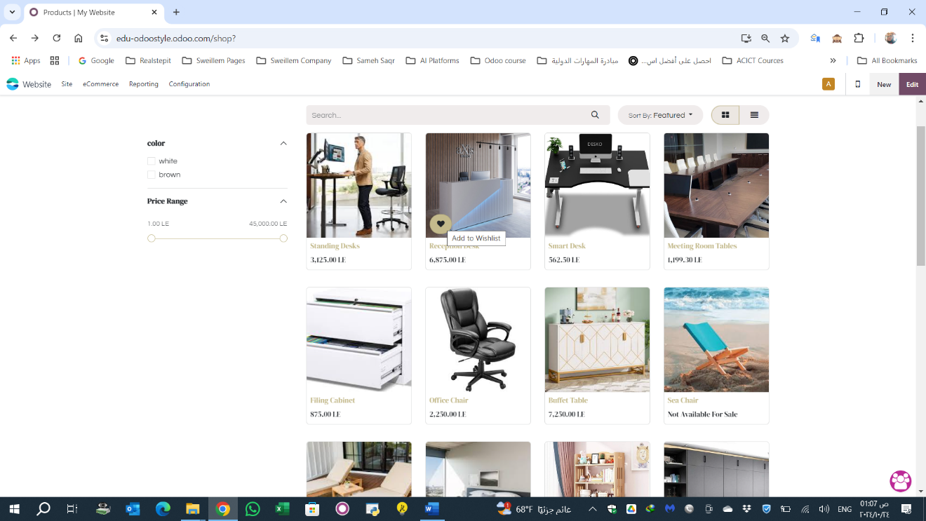

1. determine the product to buy.

1. Picking it to his cart by the quantities.

1. paying and receive his invoice

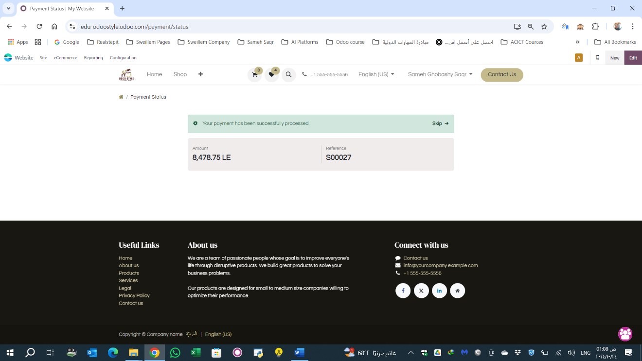

**Back end User**

1. Receiving Sales Order to (create Invoice and proceed Delivery to Customer )

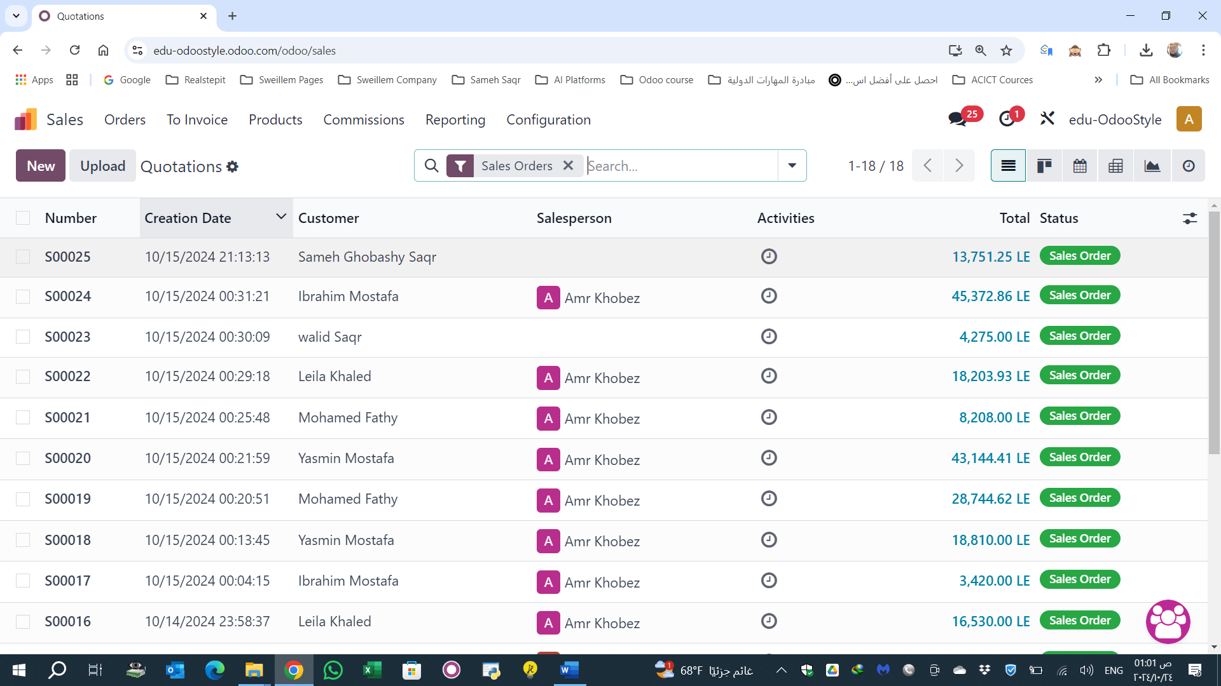

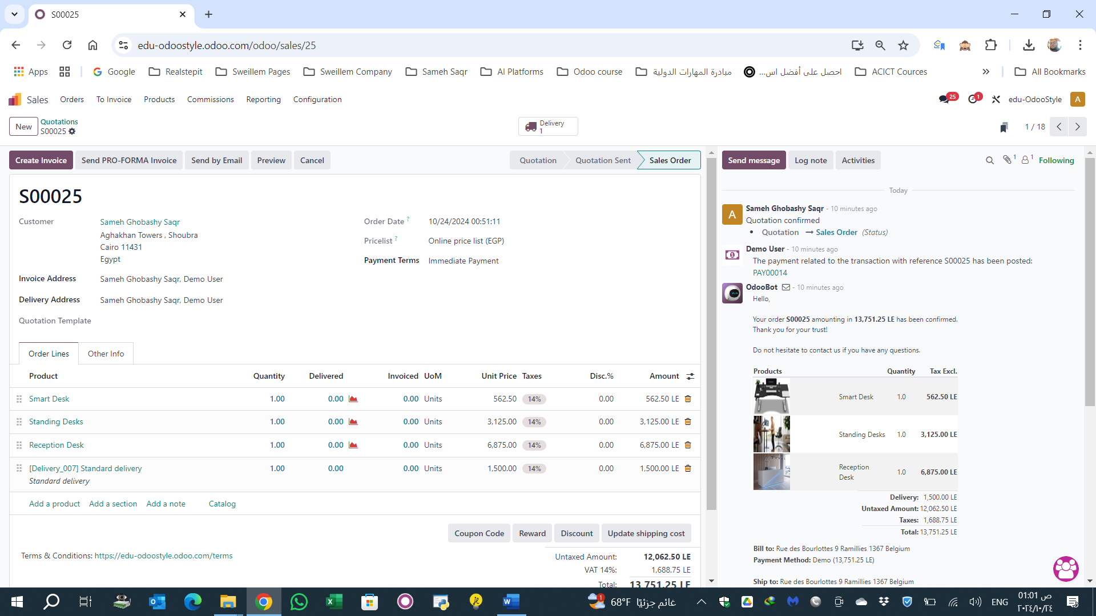

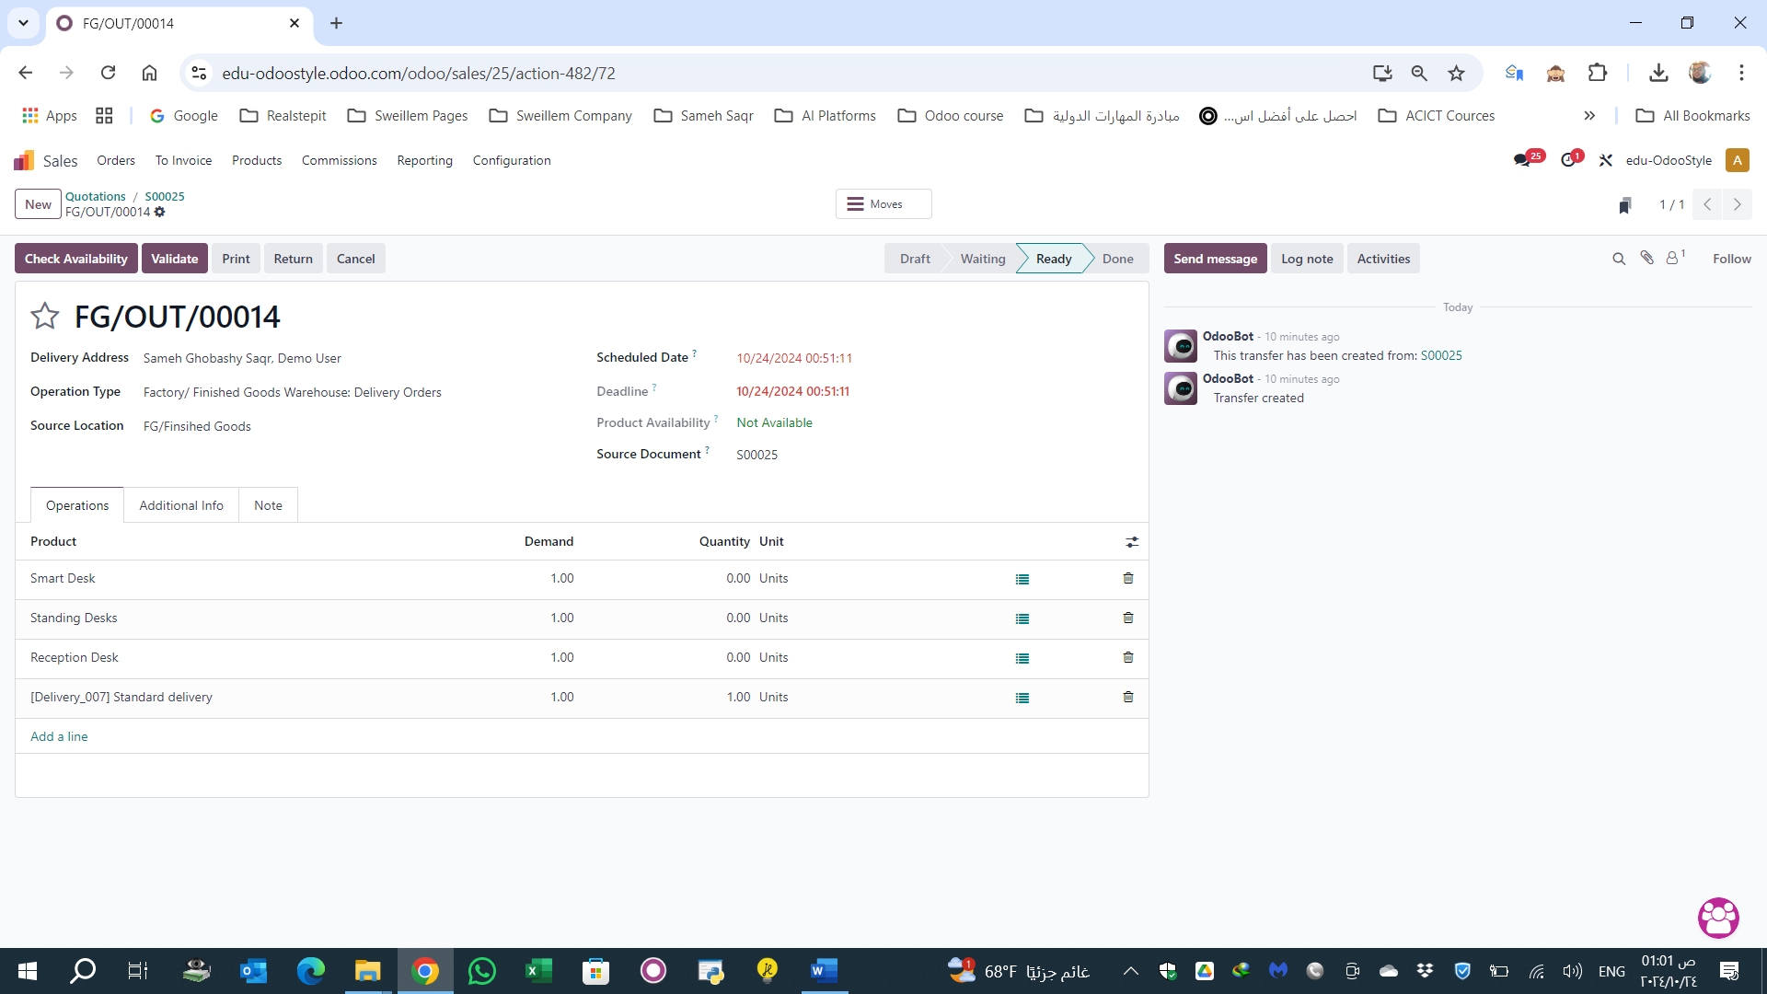

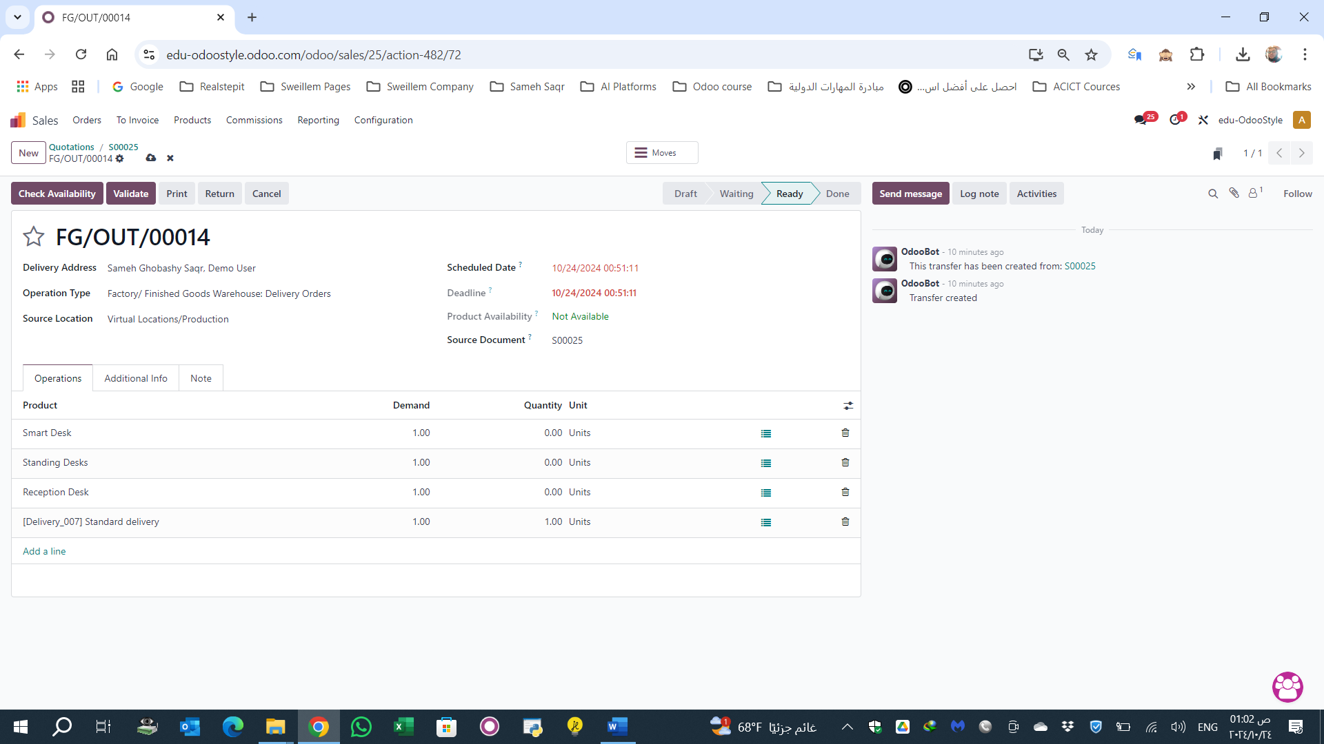

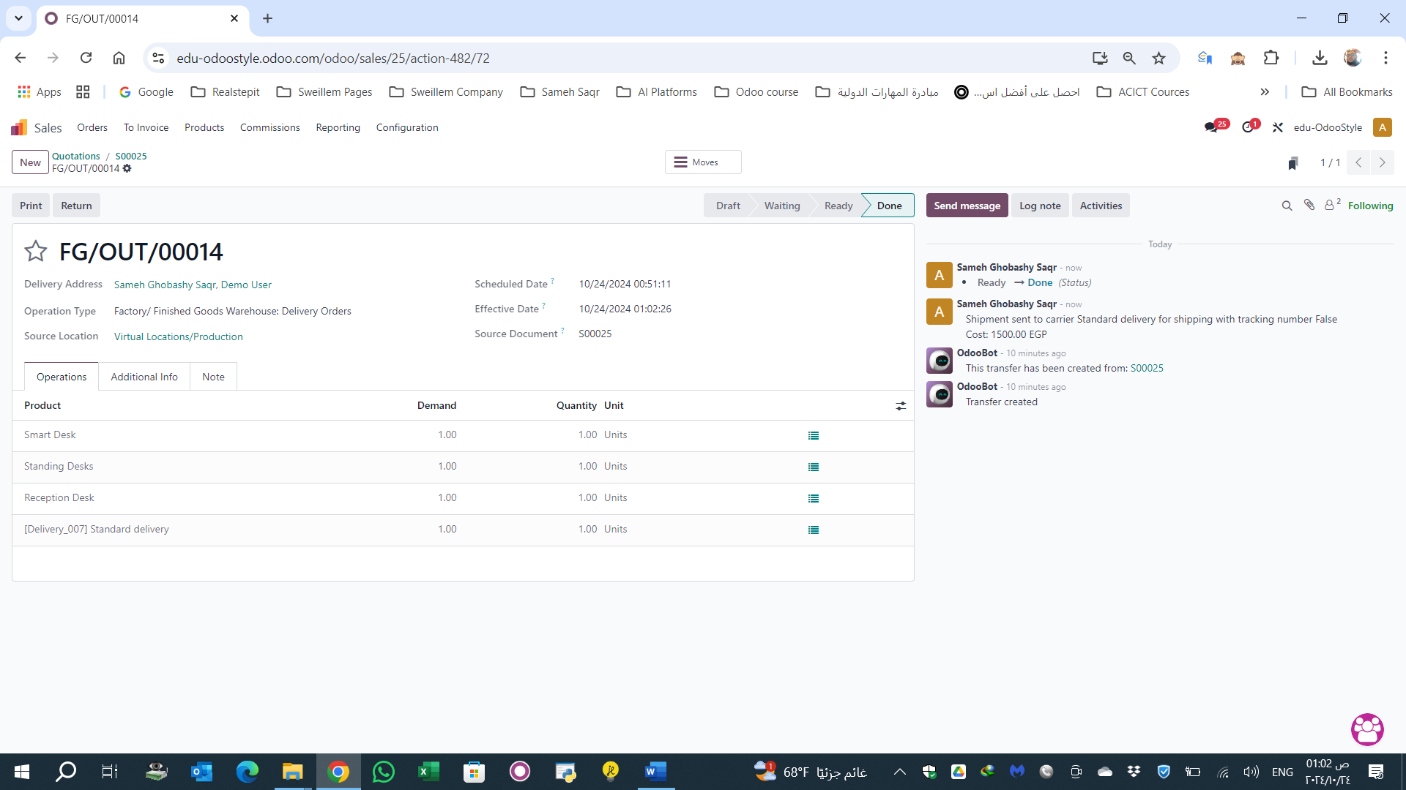

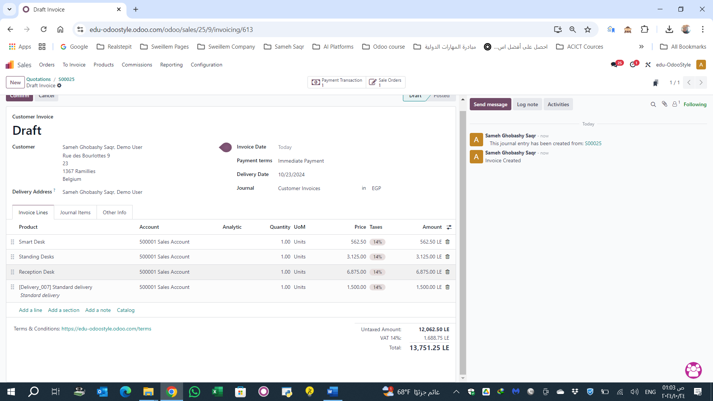

Payments

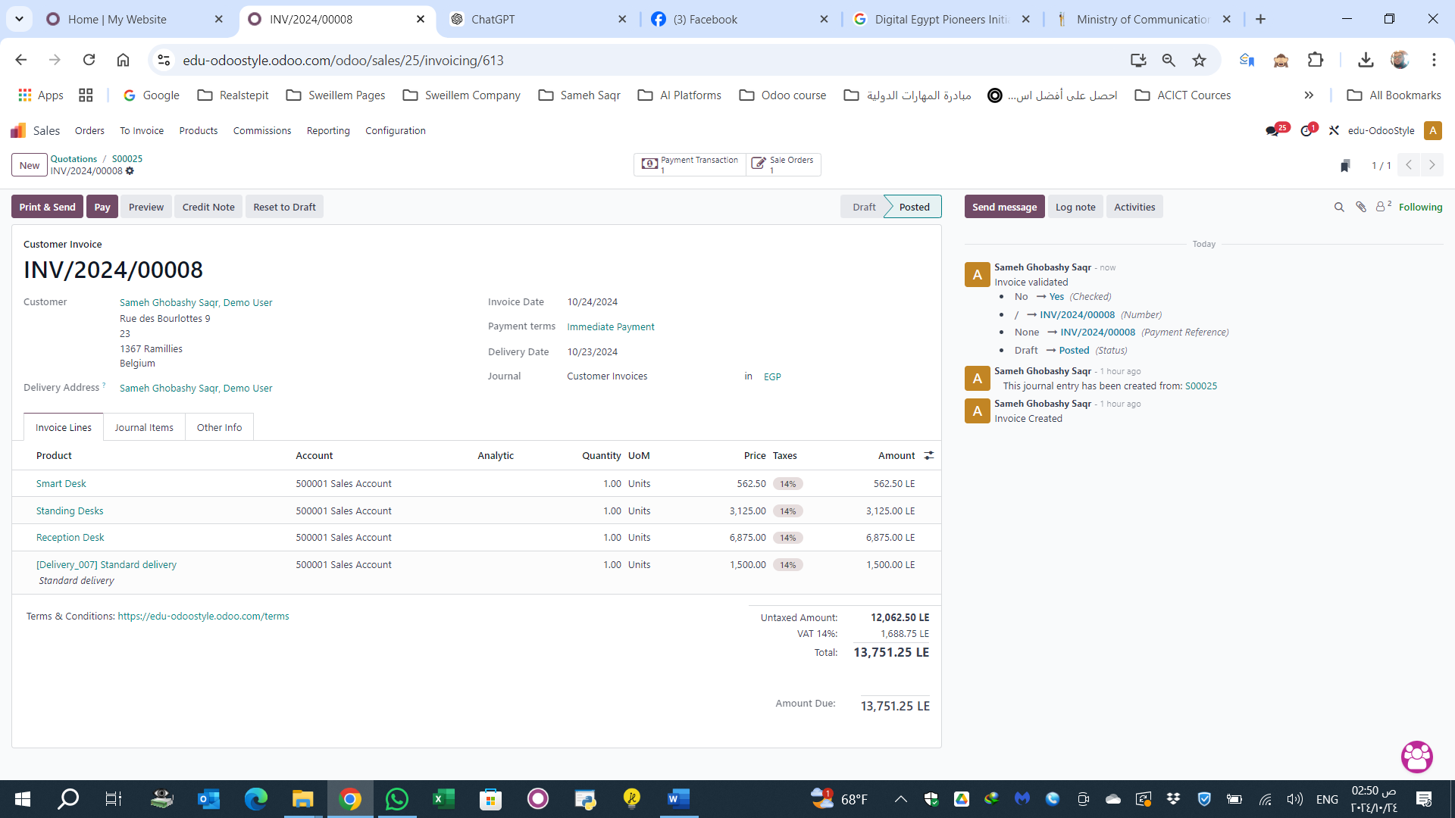

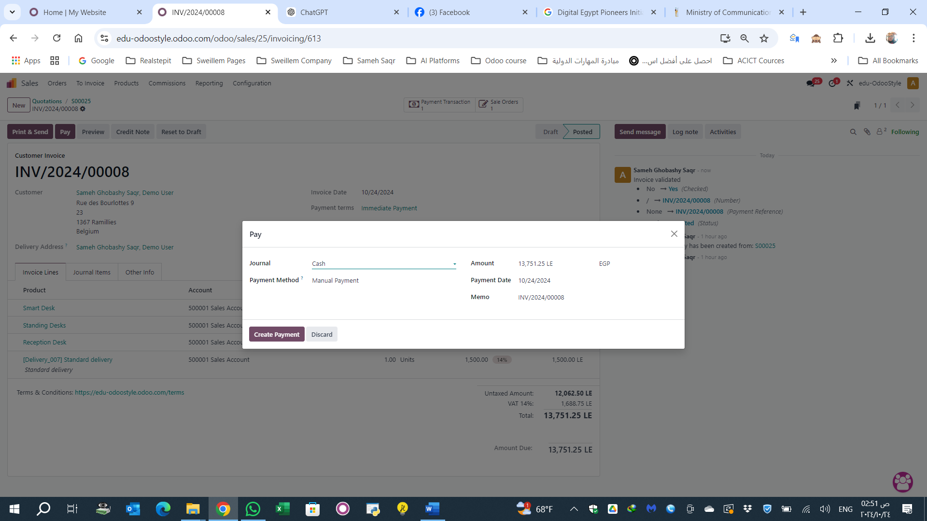

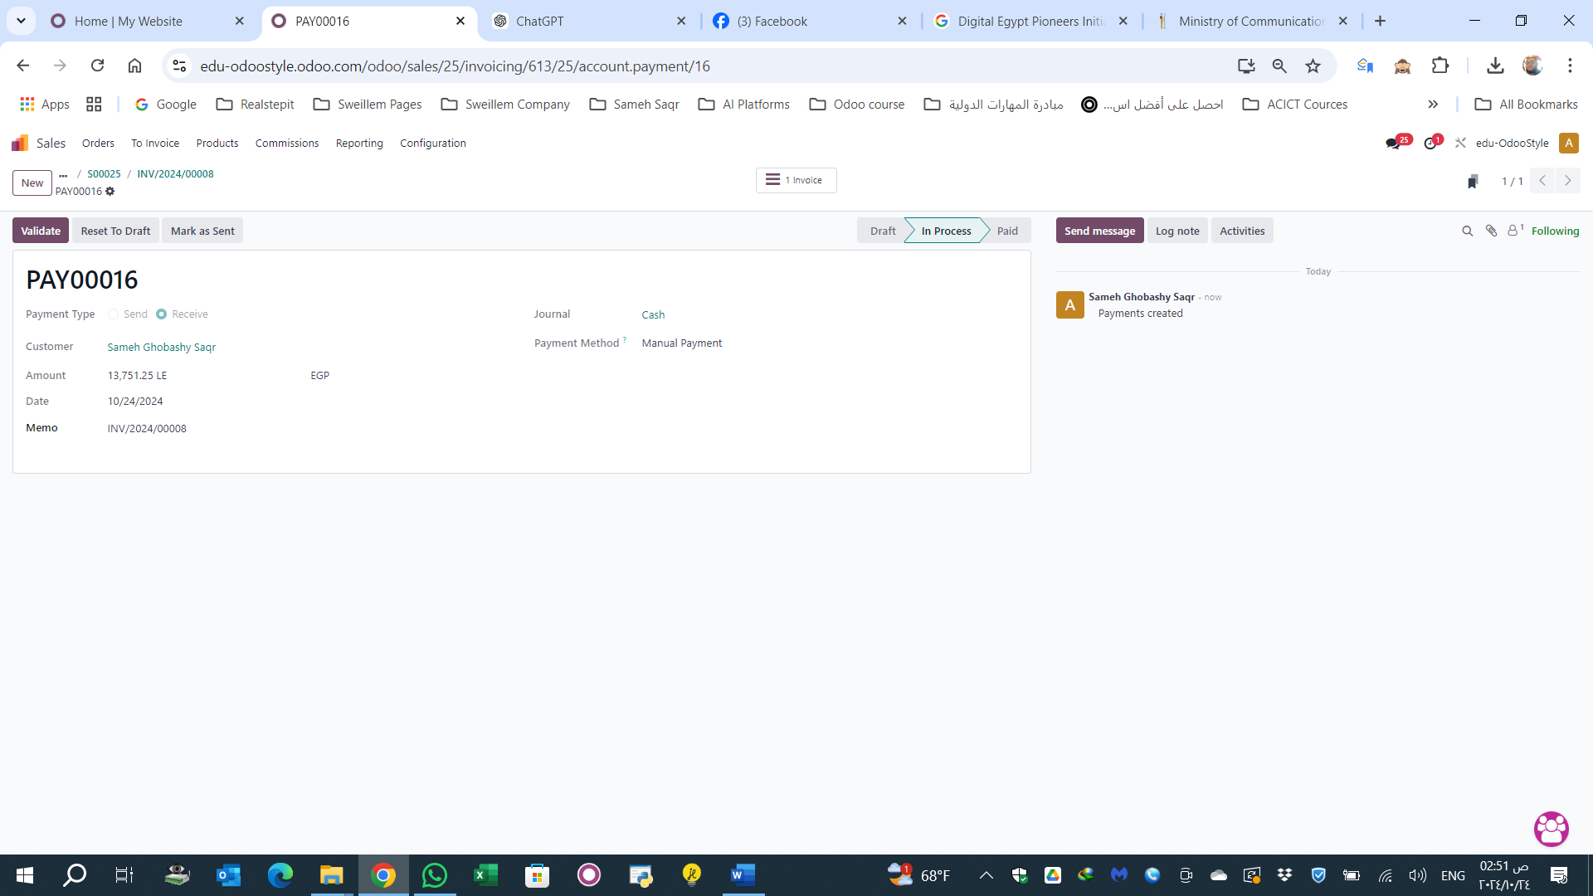

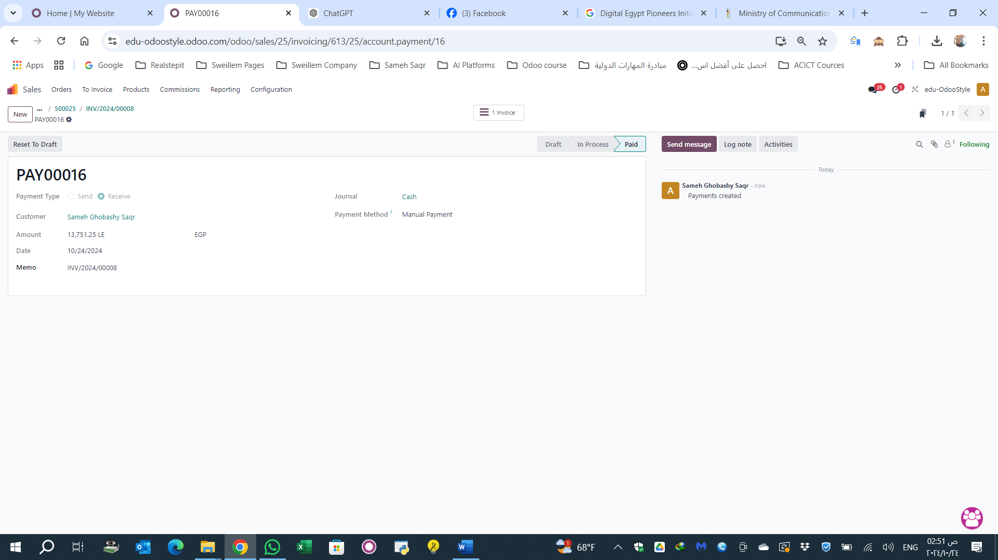

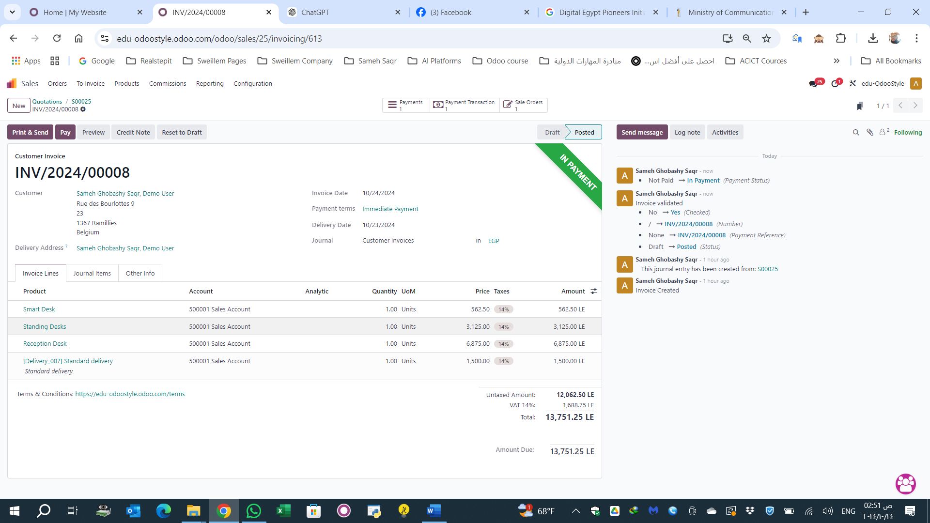

**9.HR**

**Set Up the HR Database:**

Ensure the HR module is activated through the general settings.

Configure your company by adding basic company information in “Settings.”

**Employee Setup:**

Go to the “Human Resources” module.

Create a record for each employee by navigating to “Employees” → “Create.”

Enter basic details such as name, job position, contact information, salary, and contracts.

**Manage Employment Contracts:**

From the employee section, select the employee and go to the “Contracts” tab to create a work contract.

Input contract details such as start and end dates, salary, and other terms.

**Set Up Attendance and Timesheets:**

Set up working schedules in the “Employee Attendance” module, defining work hours and breaks for each employee.

Track employee check-ins and check-outs daily.

**Leave Management:**

Through “Employee Leaves,” employees can request leave, and it can be tracked and managed.

Manage different types of leaves such as annual, sick, or emergency leave.

**Payroll Setup:**

Ensure the “Payroll” module is activated in the HR settings.

Create salary structures and add various rules like deductions and bonuses.

Payroll will be automatically calculated based on the employee’s contract and attendance.

Thank You